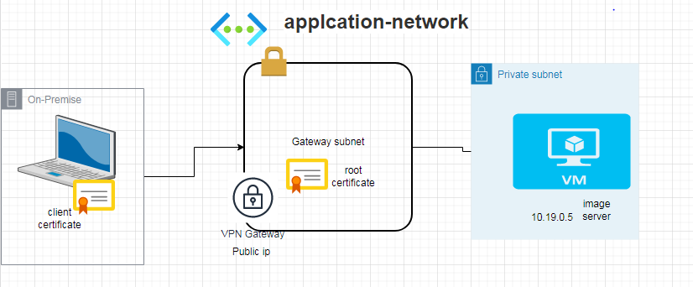

$cert = New-SelfSignedCertificate -Type Custom -KeySpec Signature -Subject "CN=P2SRootCert" -KeyExportPolicy Exportable -HashAlgorithm sha256 -KeyLength 2048 -CertStoreLocation "Cert:\CurrentUser\My" -KeyUsageProperty Sign -KeyUsage CertSign

New-SelfSignedCertificate -Type Custom -DnsName P2SChildCert -KeySpec Signature -Subject "CN=P2SChildCert" -KeyExportPolicy Exportable -HashAlgorithm sha256 -KeyLength 2048 -CertStoreLocation "Cert:\CurrentUser\My" -Signer $cert -TextExtension @("2.5.29.37={text}1.3.6.1.5.5.7.3.2")

Link -> https://stepinlogic.com/configure-azure-point-to-site-vpn/

